72. Configuring content policies of editable template in AEM.

Content policies define the design properties of a component.

For example components available for a particular layout container.

Content policies are applicable to the template and page created from the template. Content policies can be created in the Template editor of the touch optimized UI.

**Steps involved to create policies:**

1. Go to the template that was created, and place the Layout container component on the template.
2. Before we create any policies, unlock the container.

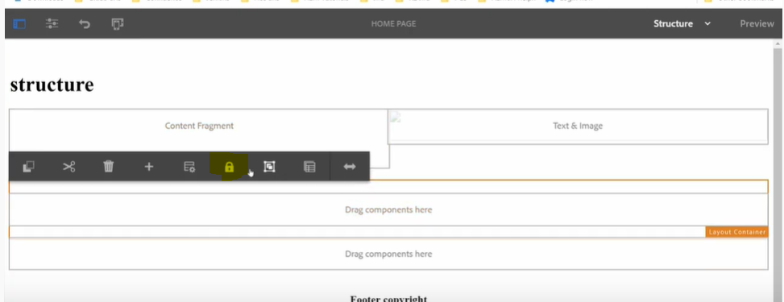

1. After unlocking the container, click on the layout container and click policy icon.

Initially there will not be any components available by default to these container, so the container place holder would display the message “No allowed components for Layout Container”.

Once the components are allowed, that list would get displayed for this container instead of the text message.

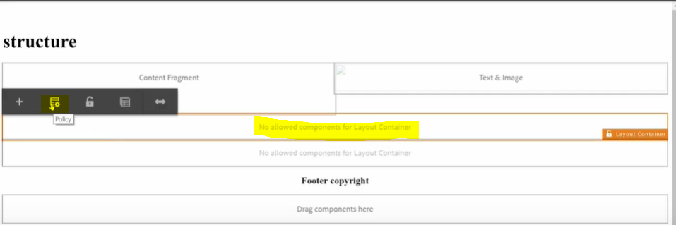

After clicking on policy icon, we would see a popup screen as mentioned below.

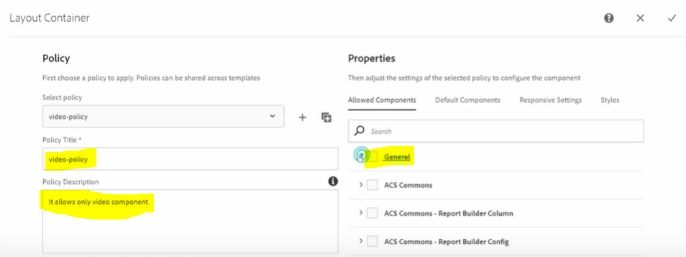

Here we can even select the existing policy, if already created. If not, the newly added policy would be auto selected in the policy dropdown.

Fill in the required details and select the components from allowed components tab.

Here in this case, we are going to select only the video component, as we want the layout container to use this video component alone.

After adding the policy, we would see this selected component as allowed one in the layout container.

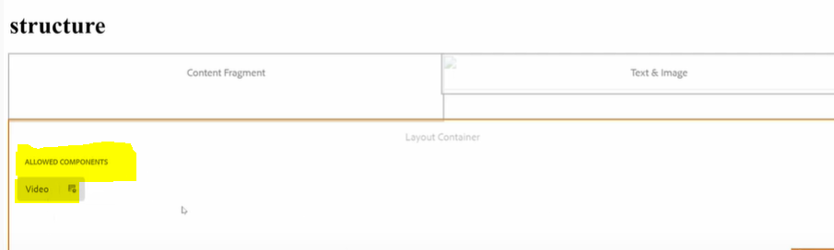

If we add more components, all that list would be displayed here on layout container.

Ex: Lets add all the image related components.

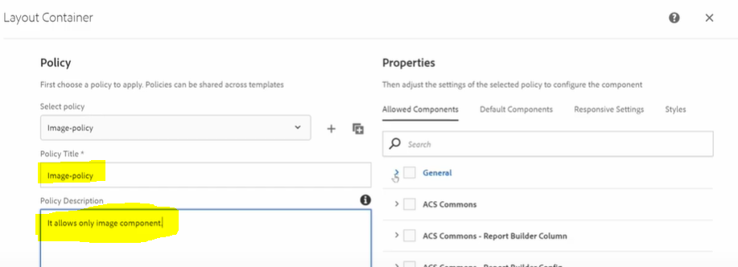

After adding all the list of image related components from the allowed components tab, the container looks like displayed below.

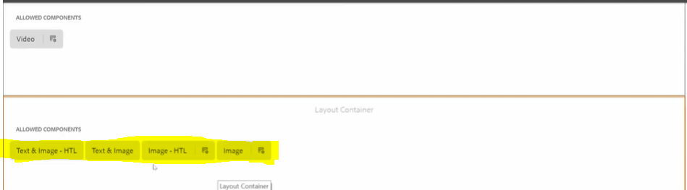

Author will be able to add only these list of allowed components on the page.